**POC: Generic Email Notification Utility**

This POC module will allow sending an email notification. This feature will be designed as generic in case any new application needs the send an email notification this module can be reused there without doing changes.

**Technologies Used:**

1. Java 11 as a Programming language
2. Spring boot framework 3.0.1
3. MySQL as a database
4. Gmail SMTP Settings
5. **Tools Used:** Spring tool Suite, MySQL workbench, Postman for testing API

**Steps:**

|  |  |  |
| --- | --- | --- |
| **Sr No** | **Description** | **Comments** |
| **1.** | Overview of POC |  |
| **2.** | Installation of MySQL database | **If you have MySQL installed and running you can skip this video** |
| **3.** | Get the Database ready with the required Tables |  |
| **4.** | Java + Spring Tool Suite installation | **If you have the development environment setup ready you can skip this video** |
| **5.** | Programming using Java + Spring boot |  |
| **6.** | How to set up an SMTP Gmail server? |  |
| **7.** | Review, Manual Testing & Possible enhancements |  |

**Note: I am doing all these implementations on Windows 11 system. There can be minor changes based on the system and environment used for implementation.**

**Sample Mail -1**



**Sample Mail -2**

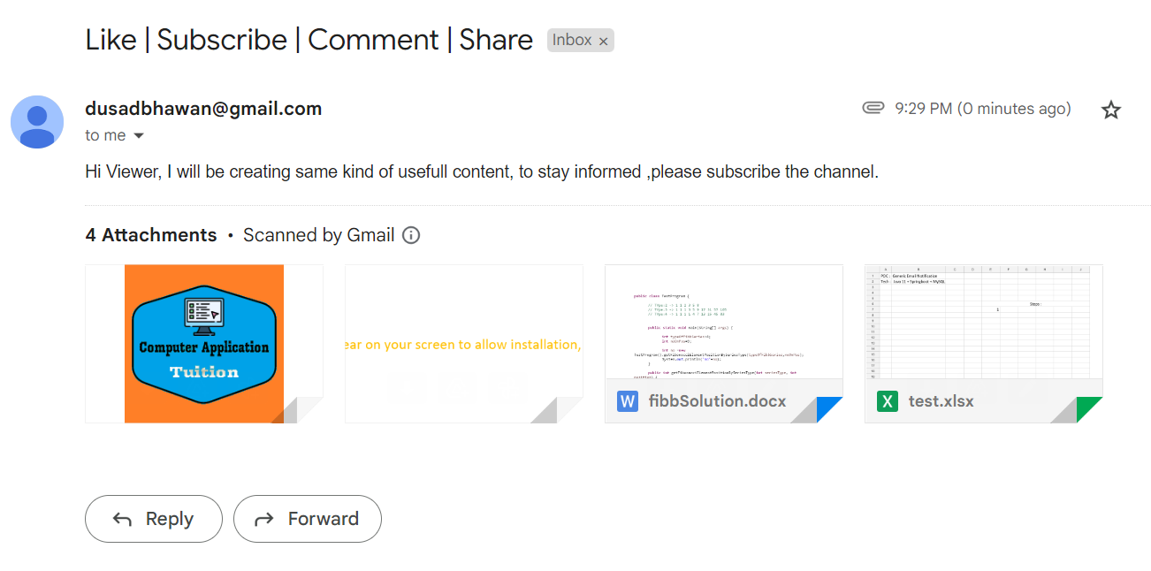

**Sample Mail – 3**

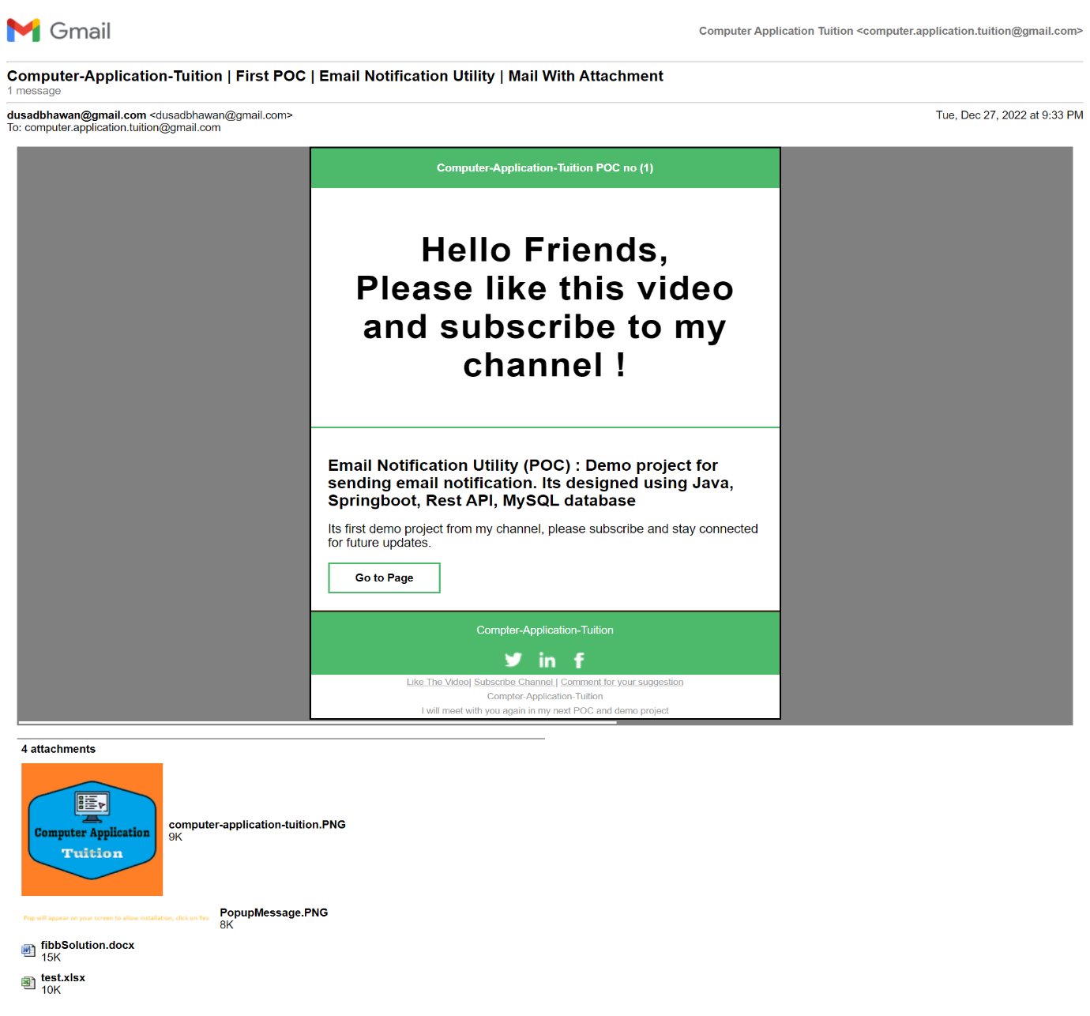

**Sample Mail – 4**

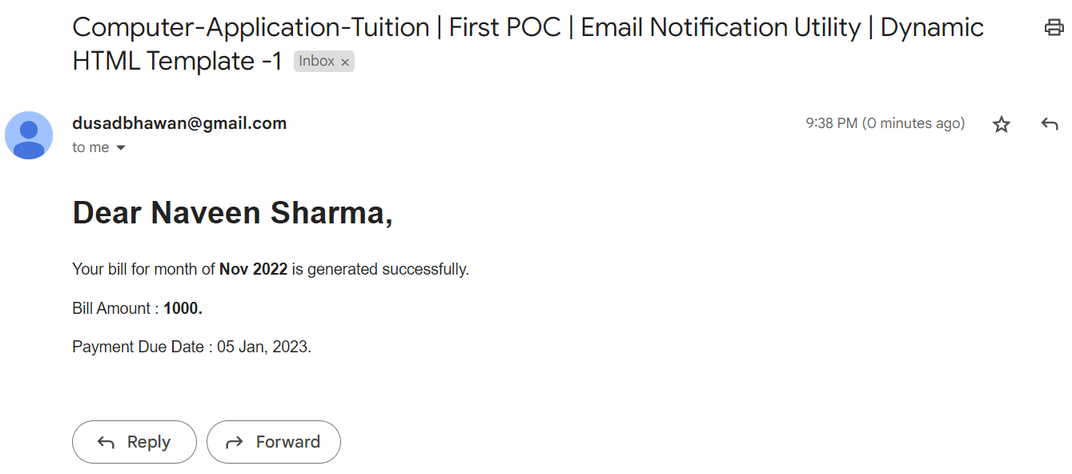

**Sample Mail-5**

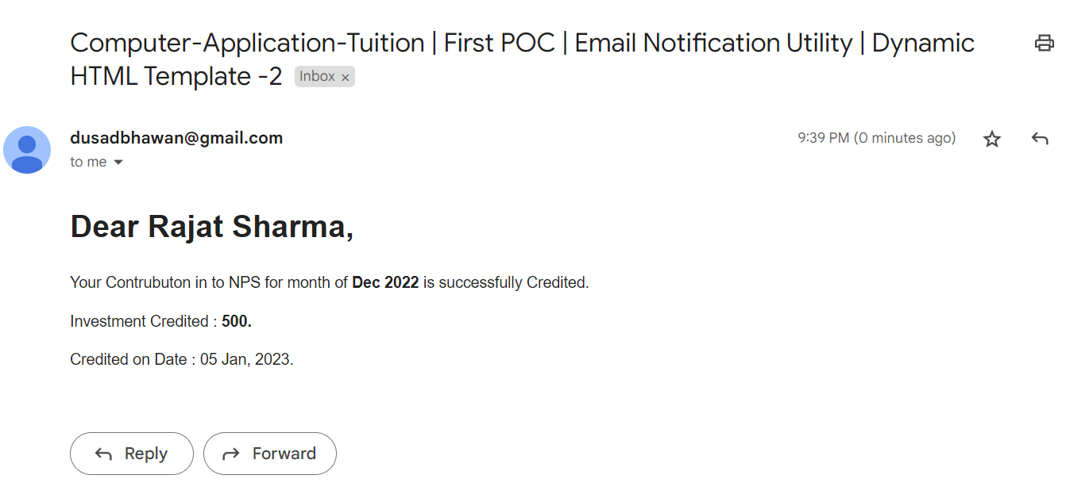

**Thanks for watching!**